**Release Note My Dashboard**

14th April 2018

“My Dashboard” would render Box type dashboard items which are created in **WorkFlow Dashboard** Joomla application. The rendering of Box Type is not done in the **Workflow Dashboard** Joomla application and alternatively a single page application was developed to meet ad-hoc requirement.

The Application Files consists of:-

MyDashboard.asp

TableList.asp

joomla.udl

baan.udl

The Database consists of IJTPerks.dbo.WF_newUserDB which has the Dashboard record data.

The application is to be uploaded into WebDB1 virtual directory of cloud web server

The Dashboards will be rendered as follows

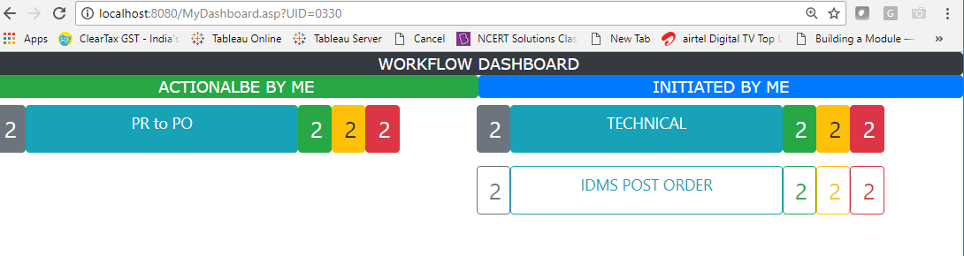

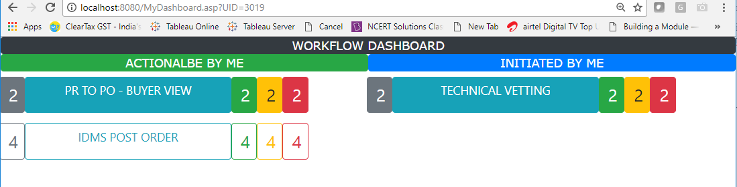

Functionality covered.

Show Dashboard App Name as Title and show Numeric value for Total, Green, Amber and Red boxes. All the Numeric boxes has hyper link to Table View and External URL. The Numeric values are resukts of respective SQL statement which is to return “COUNT” of records.

The Dashbaord has to be called with a query string UID=xxxx

Caveats

Application not tested with BaaN database related SQL queries